1. **CHEF Table**

create sequence sq

start with 101

increment by 1

maxvalue 105

minvalue 100

insert into chef (ch_id, ch_name, address) values (sq.nextval, 'Arafat', 'Sector 14 Uttara')

insert into chef (ch_id, ch_name, address) values (sq.nextval, 'Mominul', 'Sector 11 Uttara')

insert into chef (ch_id, ch_name, address) values (sq.nextval, 'Shakib', 'Dhanmondi')

insert into chef (ch_id, ch_name, address) values (sq.nextval, 'Mannan', 'Gulshan')

insert into chef (ch_id, ch_name, address) values (sq.nextval, 'Karim', 'Abdullahpur')

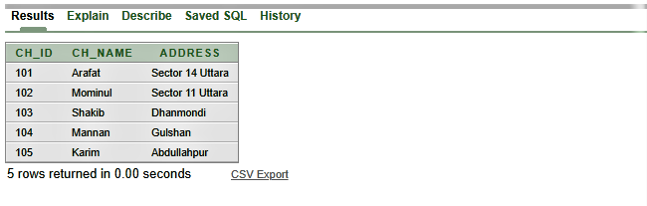

**2. ICE_CREAM Table**

create sequence sq1

start with 101

increment by 1

maxvalue 105

minvalue 101

insert into Ice_cream (i_name, i_flavour, i_price, i_quantity, ch_id) values ('Chery ice cream', 'Chery', 200, 01, sq1.nextval)

insert into Ice_cream (i_name, i_flavour, i_price, i_quantity, ch_id) values ('Chocolate ice cream', 'Chocolate', 190, 03, sq1.nextval)

insert into Ice_cream (i_name, i_flavour, i_price, i_quantity, ch_id) values ('Cone ice cream', 'vanilla', 180, 05, sq1.nextval)

insert into Ice_cream (i_name, i_flavour, i_price, i_quantity, ch_id) values ('Cup ice cream', 'Black forest', 210, 4, sq1.nextval)

insert into Ice_cream (i_name, i_flavour, i_price, i_quantity, ch_id) values ('Blue Moon ice cream', ' Dark Blue', 380, 2, sq1.nextval)

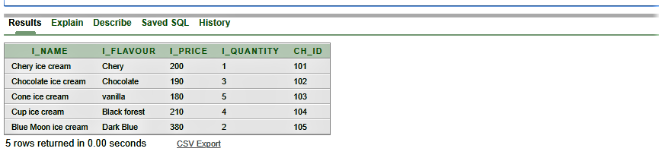

1. **SUPPLY Table**

create sequence sq2

start with 201

increment by 1

maxvalue 205

minvalue 201

insert into Supply ( sup_id, sup_name, sup_quantity, I_name ) values(sq2.nextval, 'Polar', 1000, 'Chery ice cream')

insert into Supply ( sup_id, sup_name, sup_quantity, I_name ) values(sq2.nextval, 'Igloo', 1500, 'Chocolate ice cream')

insert into Supply ( sup_id, sup_name, sup_quantity, I_name ) values(sq2.nextval, 'Bellisimo', 500, 'Cone ice cream')

insert into Supply ( sup_id, sup_name, sup_quantity, I_name ) values(sq2.nextval, 'Quality', 1200, 'Cup ice cream')

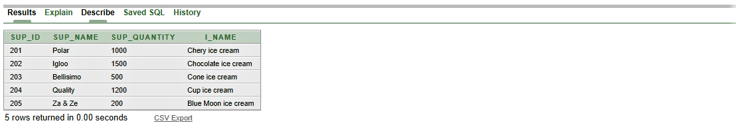insert into Supply ( sup_id, sup_name, sup_quantity, I_name ) values(sq2.nextval, 'Za & Ze', 200, 'Blue Moon ice cream')

1. **Waiter Table**

create sequence sq3

start with 301

increment by 1

maxvalue 305

minvalue 301

insert into Waiter( W_id, W_name, W_phone, Salary, I_name) values (sq3.nextval, 'Mushfiq', 01784444256, 900, 'Chery ice cream')

insert into Waiter( W_id, W_name, W_phone, Salary, I_name) values (sq3.nextval, 'Kalam', 01884444256, 2000, 'Chocolate ice cream')

insert into Waiter( W_id, W_name, W_phone, Salary, I_name) values (sq3.nextval, 'Maruf', 01584444257, 9000, 'Cone ice cream')

insert into Waiter( W_id, W_name, W_phone, Salary, I_name) values (sq3.nextval, 'Rahim', 01484444259, 5000, 'Cup ice cream')

insert into Waiter( W_id, W_name, W_phone, Salary, I_name) values (sq3.nextval, 'Sakib', 01384444251, 4000, 'Blue Moon ice cream')

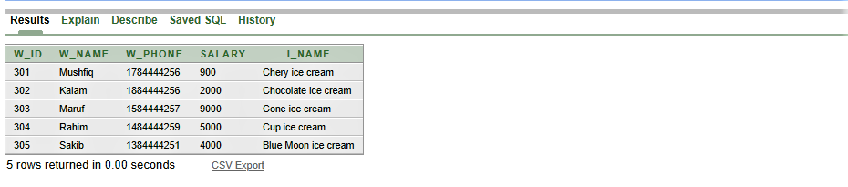

1. **Manager Table**

create sequence sq4

start with 401

increment by 1

maxvalue 405

minvalue 401

insert into manager (M_id, M_name, M_phone, W_id) values (sq4.nextval, 'Kuddus', 018387584858, 301)

insert into manager (M_id, M_name, M_phone, W_id) values (sq4.nextval, 'Akkas', 019387584858, 302)

insert into manager (M_id, M_name, M_phone, W_id) values (sq4.nextval, 'Zoshim', 015387584858, 303)

insert into manager (M_id, M_name, M_phone, W_id) values (sq4.nextval, 'Dipjol', 016387584858, 304)

insert into manager (M_id, M_name, M_phone, W_id) values (sq4.nextval, 'Manna', 014387584858, 305)

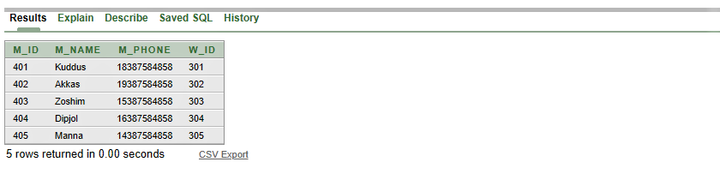

1. **Owner Table**

create sequence sq5

start with 501

increment by 1

maxvalue 505

minvalue 501

insert into Owner(O_id, O_phone, M_id) values (sq5.nextval, 01632113754, 401)

insert into Owner(O_id, O_phone, M_id) values (sq5.nextval, 01632113755, 402)

insert into Owner(O_id, O_phone, M_id) values (sq5.nextval, 01632113756, 403)

insert into Owner(O_id, O_phone, M_id) values (sq5.nextval, 01632113757, 404)

insert into Owner(O_id, O_phone, M_id) values (sq5.nextval, 01632113756, 405)

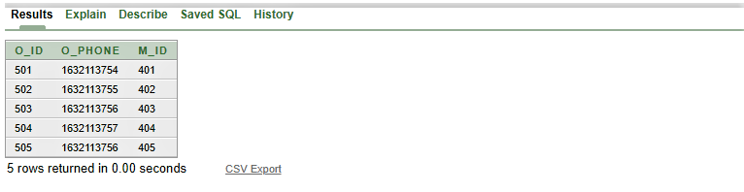

1. **Manager_Owner**

create sequence sq6

start with 401

increment by 1

maxvalue 405

minvalue 401

insert into manager_owner (M_id, M_name, M_phone, o_id) values (sq6.nextval, 'Kuddus', 018387584858, 501)

insert into manager_owner (M_id, M_name, M_phone, o_id) values (sq6.nextval, 'Akkas', 019387584858, 502)

insert into manager_owner (M_id, M_name, M_phone, o_id) values (sq6.nextval, 'Zoshim', 015387584858, 503)

insert into manager_owner (M_id, M_name, M_phone, o_id) values (sq6.nextval, 'Dipjol', 016387584858, 504)

insert into manager_owner (M_id, M_name, M_phone, o_id) values (sq6.nextval, 'Manna', 014387584858, 505)

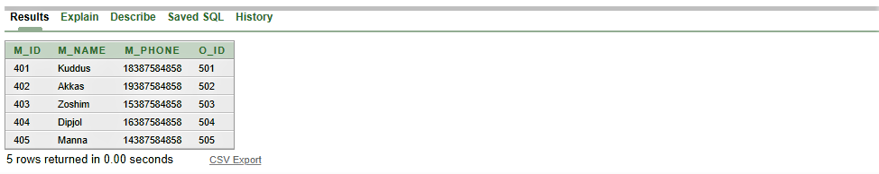

1. **Waiter_owner**

create sequence sq7

start with 301

increment by 1

maxvalue 305

minvalue 301

insert into waiter_owner( W_id, W_name, W_phone, Salary, O_id) values(sq7.nextval, 'Mushfiq', 01784444256, 900, 501)

insert into waiter_owner( W_id, W_name, W_phone, Salary, O_id) values(sq7.nextval, 'Kalam', 01884444256, 2000,502 )

insert into waiter_owner( W_id, W_name, W_phone, Salary, O_id) values(sq7.nextval,'Maruf', 01584444257, 9000, 503)

insert into waiter_owner( W_id, W_name, W_phone, Salary, O_id) values(sq7.nextval,'Rahim', 01484444259, 5000,504)

insert into waiter_owner( W_id, W_name, W_phone, Salary, O_id) values(sq7.nextval,'Sakib', 01384444251, 4000,505)

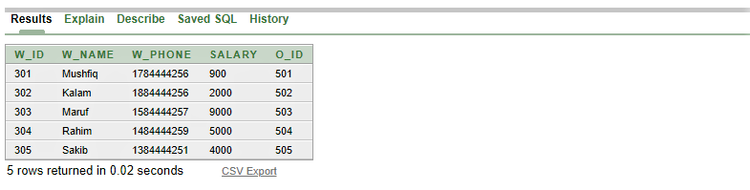

1. **Shop**

create sequence sq8

start with 701

increment by 1

maxvalue 705

minvalue 701

insert into shop(s_id, s_add) values (sq8.nextval, 'Gulshan 2')

insert into shop(s_id, s_add) values (sq8.nextval, 'Dhanmondi 32')

insert into shop(s_id, s_add) values (sq8.nextval, 'Mirpur 10')

insert into shop(s_id, s_add) values (sq8.nextval, 'Baily Road')

insert into shop(s_id, s_add) values (sq8.nextval, 'Uttara')

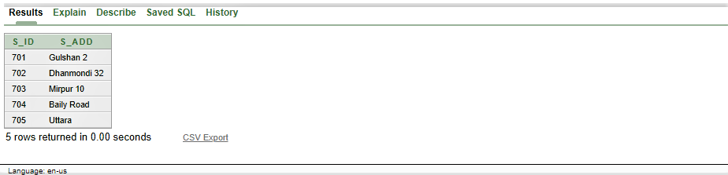

1. **Owner_shop**

create sequence sq9

start with 501

increment by 1

maxvalue 505

minvalue 501

insert into Owner_shop(O_id, O_phone,s_id) values (sq9.nextval, 01632113754,701)

insert into Owner_shop(O_id, O_phone,s_id) values (sq9.nextval,01632113755,702)

insert into Owner_shop(O_id, O_phone,s_id) values (sq9.nextval,01632113756,703)

insert into Owner_shop(O_id, O_phone,s_id) values (sq9.nextval,01632113757,704)

insert into Owner_shop(O_id, O_phone,s_id) values (sq9.nextval,01632113756,705)

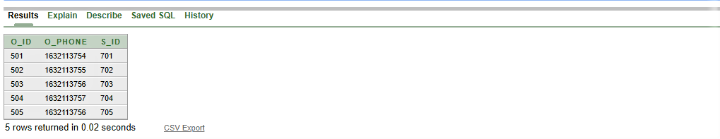

1. **Area**

insert into Area (a_id, city, country) values (1200,'Dhaka', 'Bangladesh')

insert into Area (a_id, city, country) values (1210,'Dhaka', 'Bangladesh')

insert into Area (a_id, city, country) values (1220,'Dhaka', 'Bangladesh')

insert into Area (a_id, city, country) values (1230,'Dhaka', 'Bangladesh')

insert into Area (a_id, city, country) values (1240,'Dhaka', 'Bangladesh')

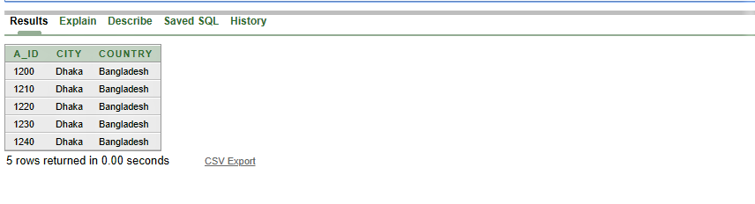

1. **Customer**

create sequence sq11

start with 1000

increment by 5

maxvalue 1020

minvalue 1000

insert into customer(C_id,C_name,C_add,C_phone,i_name) values (sq11.nextval,'Niloy','Uttara',01961951934,'Chery ice cream')

insert into customer (C_id,C_name,C_add,C_phone,i_name) values (sq11.nextval,'kalam','gulshan',01961953456,'Chocolate ice cream')

insert into customer(C_id,C_name,C_add,C_phone,i_name) values (sq11.nextval,'Amit','uttara',01961951935,'Cone ice cream')

insert into customer(C_id,C_name,C_add,C_phone,i_name) values (sq11.nextval,'Rudro','Badda',01961951935,'Cup ice cream')

insert into customer(C_id,C_name,C_add,C_phone,i_name) values (sq11.nextval,'Rokeya','Badda',01961951935,'Blue Moon ice cream')

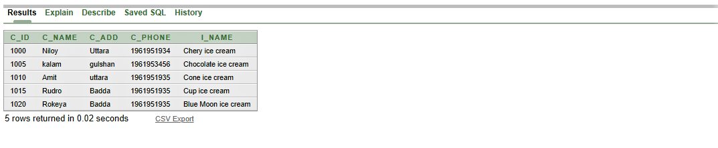

1. **Bill**

create sequence sq12

start with 1201

increment by 1

maxvalue 1205

minvalue 1201

insert into bill (b_number, amount, time, c_id) values (sq12.nextval, 120, 12.10, 1000)

insert into bill (b_number, amount, time, c_id) values (sq12.nextval, 220, 2.10, 1005)

insert into bill (b_number, amount, time, c_id) values (sq12.nextval, 300, 3.18, 1010)

insert into bill (b_number, amount, time, c_id) values (sq12.nextval, 180, 4.15, 1015)

insert into bill (b_number, amount, time, c_id) values (sq12.nextval, 500, 6.10, 1020)

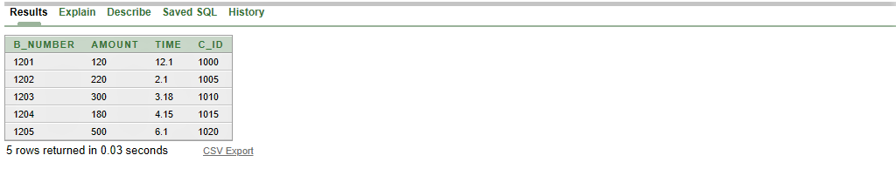

1. **Cashier**

create sequence sq13

start with 900

increment by 1

maxvalue 904

minvalue 900

insert into cashier ( ca_id, ca_name) values(sq13.nextval, 'Dildar')

insert into cashier ( ca_id, ca_name) values(sq13.nextval, 'Kazi')

insert into cashier ( ca_id, ca_name) values(sq13.nextval, 'Maruf')

insert into cashier ( ca_id, ca_name) values(sq13.nextval, 'Motin')

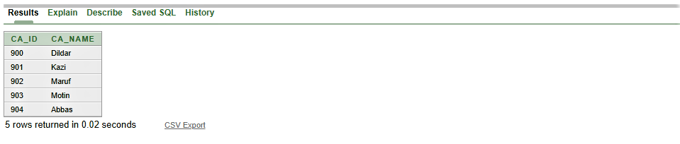insert into cashier ( ca_id, ca_name) values(sq13.nextval, 'Abbas')

1. **Cashier_bill**

create sequence sq14

start with 1201

increment by 1

maxvalue 1205

minvalue 1201

insert into cashier_bill (b_number, amount, time, ca_id) values (sq14.nextval, 120, 12.10,900)

insert into cashier_bill (b_number, amount, time, ca_id) values (sq14.nextval, 120, 2.10,901)

insert into cashier_bill (b_number, amount, time, ca_id) values (sq14.nextval, 120, 3.18,902)

insert into cashier_bill (b_number, amount, time, ca_id) values (sq14.nextval, 120, 4.15,903)

insert into cashier_bill (b_number, amount, time, ca_id) values (sq14.nextval, 120, 6.10,904)

